CO4 — AT1
Data Interpretation
Reading, Comparing & Reasoning Over Computer Vision Performance Data
Course Outcome: CO4 — Computer Vision & Object Detection Systems
Prepared with worked calculations, comparative tables, and supporting charts.

Question 1. Real-Time Detection System
Method | Accuracy | Speed
Viola-Jones | 78% | Fast
YOLO | 92% | Moderate
Deep Learning | 95% | Slow
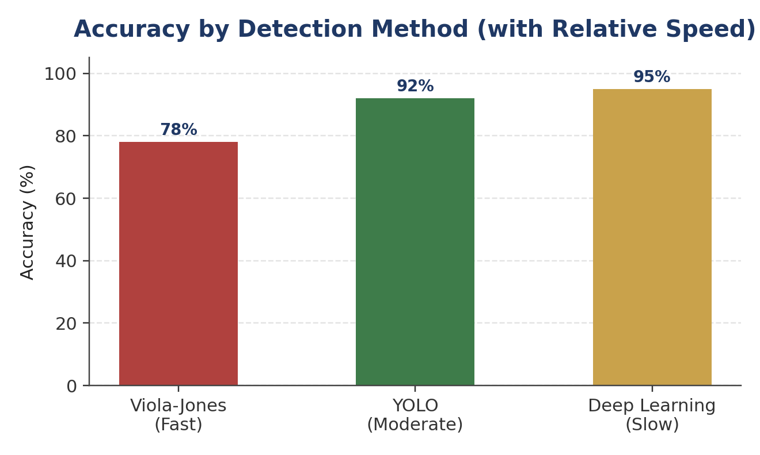
Figure 1.1 — Accuracy by method, annotated with relative processing speed.
Analysis
Under strict latency constraints, the fastest method (Viola-Jones) is attractive on speed alone, but its accuracy of 78% is considerably lower than the other two options — too low for reliable surveillance, where missed detections carry real consequences. Deep Learning gives the best accuracy (95%) but its slow processing makes it unsuitable when latency is a hard constraint, since a surveillance feed that lags behind real time defeats its own purpose. YOLO sits between the two extremes: it runs at moderate speed — fast enough for most real-time surveillance pipelines — while delivering 92% accuracy, only 3 points below Deep Learning.
✔ Conclusion: YOLO should be selected. It offers the best balance for strict latency requirements — moderate speed suitable for real-time operation, combined with accuracy (92%) high enough for reliable surveillance, without the excessive latency of Deep Learning or the accuracy shortfall of Viola-Jones.

Question 2. Robust Object Detection
Method | Normal | Occlusion | Low Light
Viola-Jones | 80% | 60% | 55%
YOLO | 90% | 75% | 70%
Deep Learning | 95% | 85% | 80%
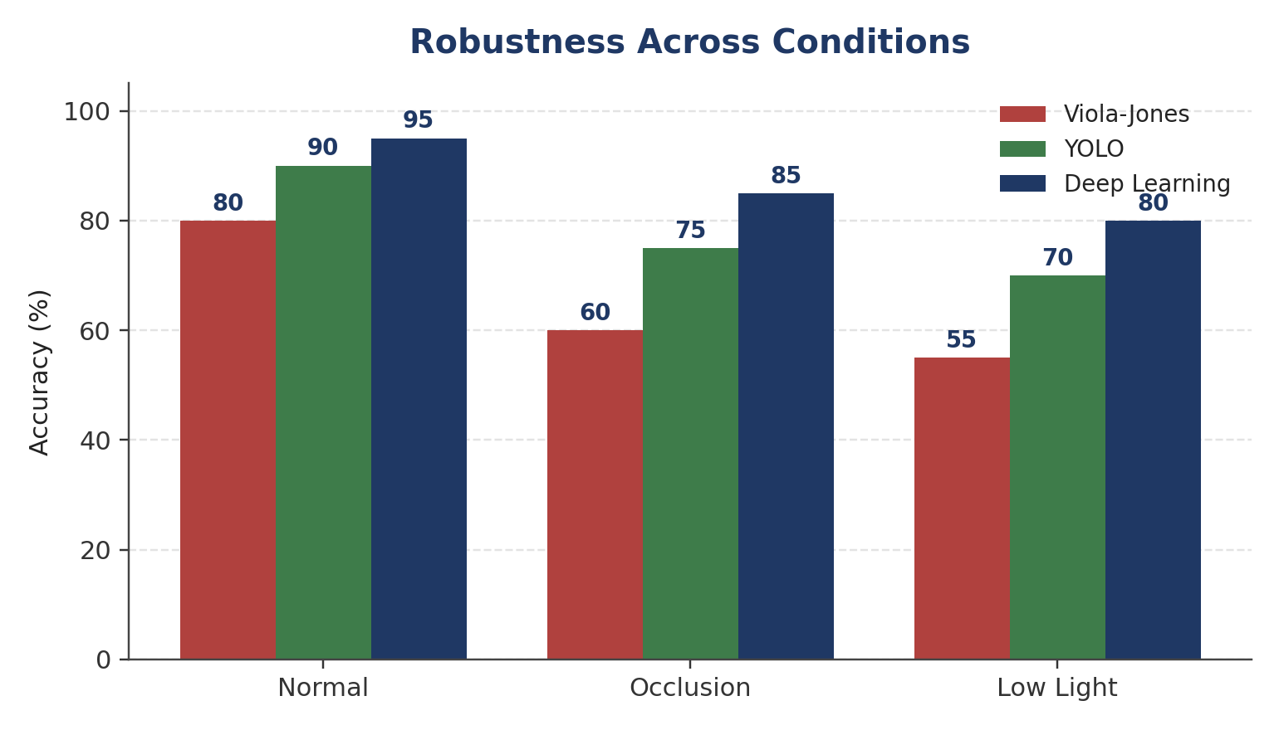
Figure 2.1 — Accuracy of each method under normal, occlusion, and low-light conditions.
Analysis
Deep Learning leads in every single condition — normal (95%), occlusion (85%), and low light (80%) — and its lead widens under harder conditions (a 25-point gap over Viola-Jones in low light, versus a 15-point gap in normal conditions). This shows Deep Learning generalizes best to challenging, real-world visual variation. YOLO is consistently second, with a moderate drop under occlusion and low light but nowhere near as severe as Viola-Jones, which degrades sharply — losing roughly 20–25 accuracy points as conditions worsen, indicating it relies heavily on clean, well-lit, unobstructed views (consistent with its hand-crafted feature-based design).
Trade-off: Deep Learning's superior robustness comes at the cost of higher computational demand and typically slower inference, so the 'best' method still depends on whether the deployment can afford that overhead.
✔ Conclusion: Deep Learning provides the best overall robustness, maintaining the highest accuracy across all three conditions, though this comes with a computational cost trade-off compared to the lighter YOLO and Viola-Jones methods.

Question 3. Optical Flow Analysis
Aspect | Method A | Method B
Motion vectors | Stable | Noisy
Small motion sensitivity | Misses small motions | Detects fine motion
Best suited for | Smooth, large-scale motion | Detailed, subtle motion
Analysis
Method A prioritizes stability: its vectors are reliable and low-noise, but it under-responds to small movements, which means subtle or fine-grained motion in a scene may go undetected entirely. Method B is more sensitive and can pick up fine motion detail, but its noisy vectors reduce reliability — noise can be mistaken for genuine motion, or genuine motion can be obscured by fluctuation.
In dynamic scenes — where objects move unpredictably, at varying scales, and often partially — capturing fine and subtle motion is usually more critical than perfect vector stability, because a method that systematically misses small movements will fail to track fast-changing or partially-occluded objects altogether. Noise, by contrast, can be mitigated using standard post-processing (e.g., temporal smoothing or a Kalman filter), whereas missed detections cannot be recovered after the fact.
✔ Conclusion: Method B is more suitable for motion tracking in dynamic scenes. Its sensitivity to fine motion is essential in fast-changing environments, and its noise — unlike Method A's blind spot for small motions — can be reduced with filtering techniques without losing genuine detections.

Question 4. Model Generalization and Overfitting — 10 Marks
Model | Training Accuracy | Testing Accuracy | Train–Test Gap
Model A | 98% | 70% | 28 pts
Model B | 90% | 88% | 2 pts
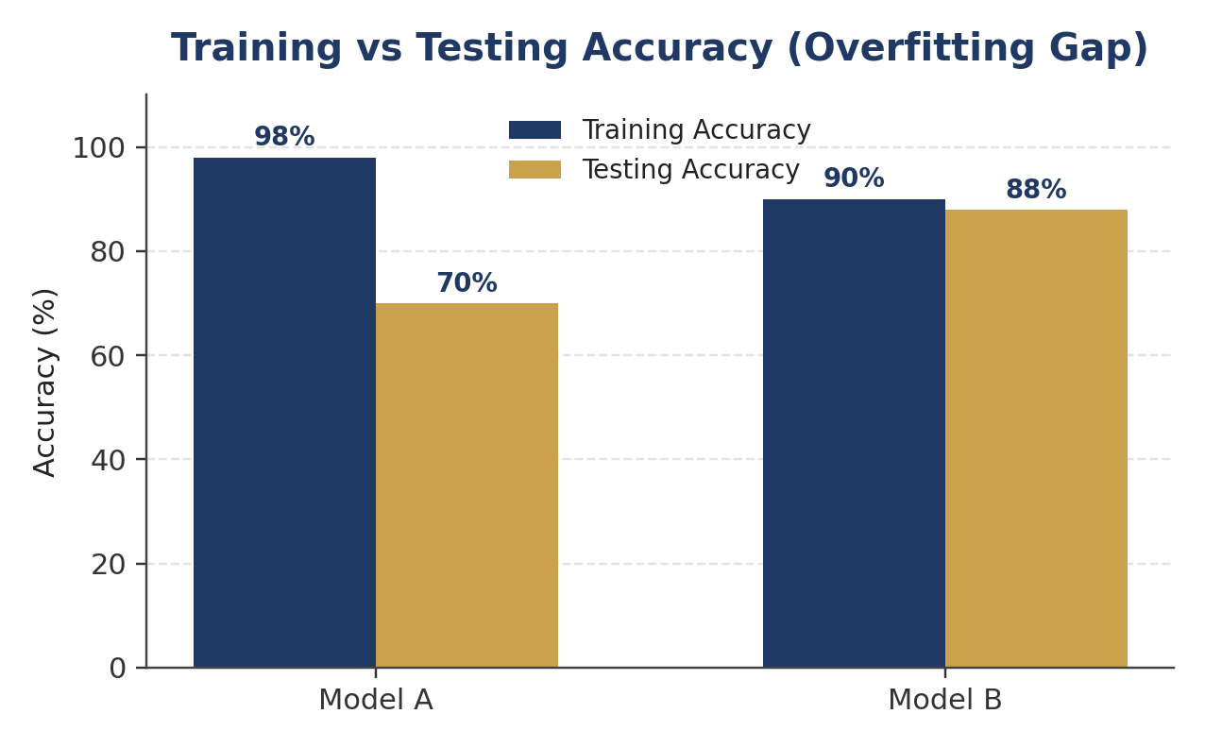
Figure 4.1 — Training vs testing accuracy for Model A and Model B.
Analysis
Model A achieves the highest training accuracy (98%) but its testing accuracy collapses to 70%, a 28-point gap. This large gap is the signature of overfitting: the model has essentially memorized patterns specific to the training set (including noise) rather than learning features that generalize, so it performs poorly on unseen data.
Model B has a lower training accuracy (90%) but a nearly matching testing accuracy (88%), a gap of only 2 points. This small, stable gap indicates the model has learned genuinely generalizable patterns rather than memorizing the training data, and its performance on new, unseen inputs can be trusted to resemble its training-time performance.
✔ Conclusion: Model B is more reliable for real-world deployment. Its small train-test gap shows strong generalization and low overfitting risk, whereas Model A's high training accuracy is misleading — its real-world performance would likely resemble its low 70% testing accuracy, not its 98% training accuracy.

Question 5. System Performance under Constraints
Model | Accuracy | Latency | Cost
Model A | 88% | 50 ms | Low
Model B | 92% | 80 ms | Moderate
Model C | 95% | 120 ms | High
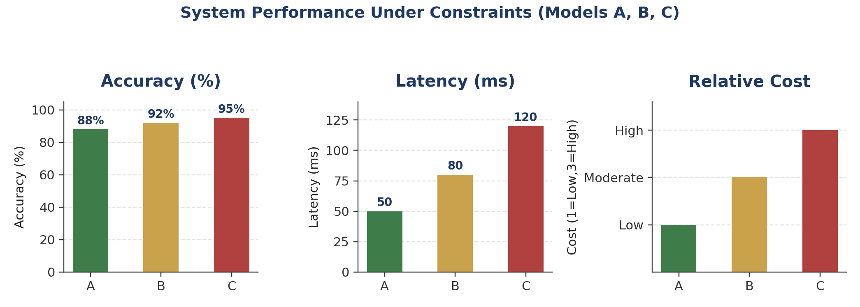
Figure 5.1 — Accuracy, latency, and relative cost for Models A, B, and C.
Analysis
Model A is fastest (50 ms) and cheapest (Low cost), but its 88% accuracy is the weakest of the three — acceptable only where mistakes are low-stakes. Model C reaches the highest accuracy (95%) but at 120 ms latency and High cost, it is poorly suited to real-time use — the added 70 ms over Model A is a substantial delay for a live application, and High cost limits scalability.
Model B sits in the middle on every dimension: a meaningful accuracy gain over Model A (+4 points) for a moderate latency increase (+30 ms) and only a moderate cost increase — without the steep latency and cost penalty that comes with Model C's marginal further accuracy gain (+3 points for +40 ms and a jump to High cost). For a real-time application, where responsiveness matters as much as raw accuracy, Model B's balance of reasonable accuracy, tolerable latency, and moderate cost makes it the most practically deployable option.
✔ Conclusion: Model B offers the best overall balance of accuracy, latency, and cost for a real-time application — it captures most of the accuracy benefit of Model C without its unacceptable latency and cost, while clearly outperforming Model A on accuracy.

